Project 3: Convolution (Matched Filtering)

Introduction
The acquisition of a signal in a digital communications system requires the convergence of several signal processing technologies. The major receiver technologies are (1) ADC., (2) timing recovery, (3) carrier recovery, (4) channel equalization, (5) signal detection, and (6) matched filtering (convolution).

Matched filtering

Practical receivers often estimate the transmitted signal by using a technique known as matched filtering. A receiver employing such a technology filters the received signal with a filter whose shape is “matched” to the transmitted signal’s pulse shape. The matched filter’s pulse shape is a time-reversed version of the transmit pulse shape. Thus, if the transmit pulse shape h(t) is known to be:

h(t) for 0 ≤ t ≤ T

then the matched filter’s response h_{m}(t) is:

h_{m}(t) = h(T–t) for 0 ≤ t ≤ T

Such processing provides two advantages. By filtering the received signal with a matched filter, only the frequencies contained in the transmitted signal’s spectrum are process while the remaining frequencies are ignored or nulled. Therefore matched filters limit the amount of the noise that is passed on to subsequent receiver stages, maximizing the receiver’s SNR. A second advantage is that a matched filter correlates the received signal with the transmit pulse shape over the symbol period T. Such processing results in a correlation gain by integrating the received signal energy while averaging out the zero-mean AWGN.

An example of matched filtering is shown in Figure 1.

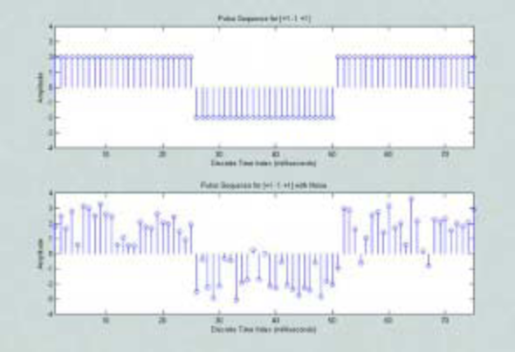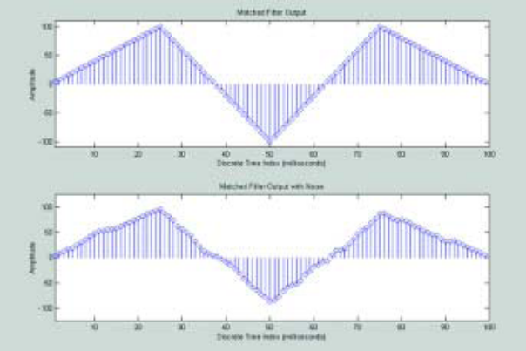
1
1
-1
1
1
-1
1
1
-1
Figure 1: Signal with and without noise (left) and their matched filter outcomes (right) measured at the end of each message period.

Spread Spectrum (Mitra)

Consider a multiuser spread spectrum communication system in which the transmitted data sequence is obtained by modulation a low-rate sequence of data symbols with a high-rate spreading sequence, that istypically chosen to be periodic pseudo-random sequence or orthogonal basis set (e,g,; Walsh functions). The elements of the spreading sequence are called chips. The number of chips per symbol is called the processing gain (denoted N). The following N=5 example illustrates how the system works.

Data (symbols) to be transmitted: m[k] = { -1 -1 +1 +1 -1}

For each of 4-distinct users a binary-valued random spreading sequences, denoted s_{i} is defined providing a processing gain N=5.

s₁: { -1 +1 -1 +1 +1}: user 1
s₂: { -1 -1 -1 -1 +1}: user 2
s₃: { -1 +1 -1 -1 +1}: user 3
s₄: { +1 -1 -1 -1 +1}: user 4

Generate an up-sampled N=5 data set of 5 symbols (note MATLAB indexing begins indexing with 1 not 0) based on m[k].
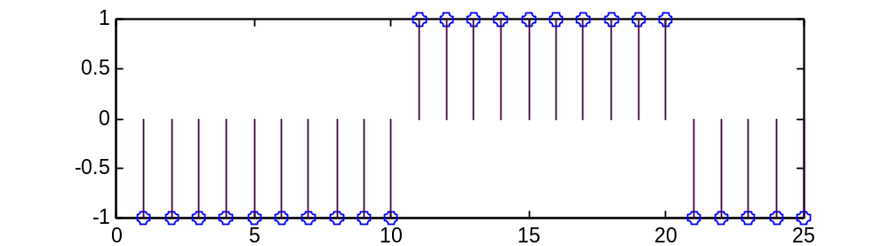
-1
1
1
-1
-1
d[k]
Figure 2: Up-sampled (by 5) slow-rate data sequence to produce d[k]=[-1 -1 -1 -1 -1 -1 -1 -1 -1 -1 1 1 1 1 1 1 1 1 1 1 -1 -1 -1 -1 -1 ] for N=5 (n∈[0,24]) based on m[k].

Suppose a message is intended for user 1. The transmitter generates a high-rate spreading sequence S₁[k] based on s₁[k].
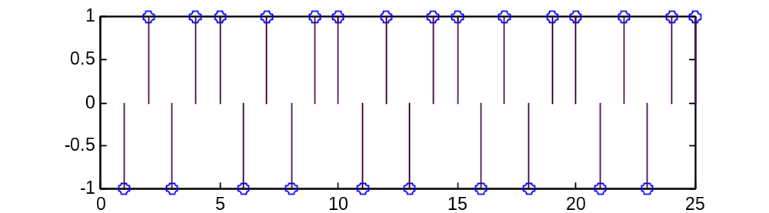
S₁[k]
s₁[k]
s₁[k]
s₁[k]
s₁[k]
s₁[k]
Figure 3: Periodic spreading sequence S₁[k]=[-1 1 -1 1 1 -1 1 -1 1 1 -1 1 -1 1 1 -1 1 -1 1 1 -1 1 -1 1 1 ] for user 1 (N=5) (n∈[0,24]) based on s₁[k] = [-1 1 -1 1 1].

Modulate the up sampled d[k] with S₁[k] (i.e., d[k]∗S₁[k] ) using point-by-point modulation.
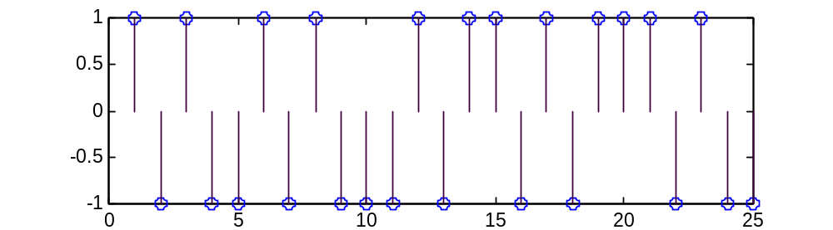
Figure 4: Product modulated sequence p[k]=[1 -1 1 -1 -1 1 -1 1 -1 -1 -1 1 -1 1 1 -1 1 -1 1 1 1 -1 1 -1] for intended user 1(N=5) (n∈[0,24]) (i.e., d[k]∗S₁[k] )

Define the digital matched filter as the reverse image of s₁[k] = [-1 1 -1 1 1], namely h_{1m}[k] = [1 1 -1 1 -1]. That is, the matched filter is the reverse image of s₁. Convolve the received signal with the matched filter h_{1m}[k].

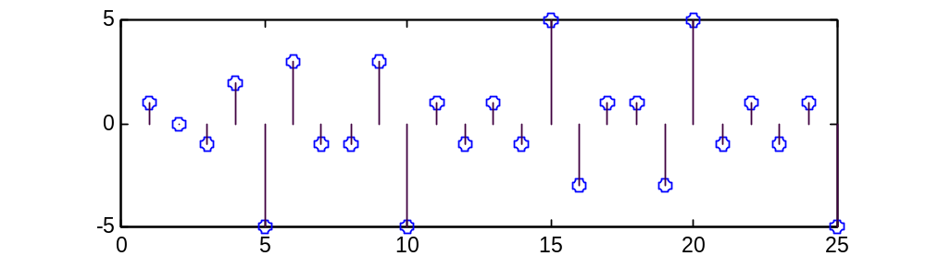
-1
-1
1
1
-1
Output of the matched filter: y₁[k] = [ 1 0 -1 2 -5 3 -1 -1 3 -5 1 -1 1 -1 5 -3 1 1 -3 5 -1 1 -1 1 -5] for user 1; (N=5) (n∈[0,24])

Notice that at the end of detached 5–sample periods (k=5, 10, 15, 20, 25), the matched filter achieves its extreme output value of ±5 corresponding to a processor gain of N=5. Using a decision threshold ±4, for example, the original message m[k] = {-1 -1 +1 +1 -1} is recovered without error. With noise present, a more careful threshold selection would be needed.

Project 3

Project 3 is an extension of the spread-spectrum N=5 example considered in the previous section.

Generate, using MATLAB:

- a 20 symbol (±1 valued) low-rate data message m[k]. For N=5, the transmitted signal d[k] consists of 100 samples.
- a user #1 N=5 random spreading sequence S₁[k]. That is, copy s₁[k] 20 times to create a periodic 100-sample signal S₁[k].
- a 100 sample product modulated signal p[k].

The modulation and match filtering as practiced in the previous example.

Q1: Using d[k] and S₁[k] (message directed to user #1), generate the matched filter output and determine the error rate for a rationale choice of decision threshold.

Q2: Repeat Q1 except use the match filter for user 2. Determine the error rate for a rationale choice of decision threshold.

Q3: Add normal noise to the message d[k] for a SNR level of your choice (SNR = 10dB to 0dB). Repeat the Q1 study and report.

Due July 17, 2015
Same format as last project.

